REVISION HISTORY
Date | Version | Description | Author
14.11.2025 | 1.1 | The work for Sections 1, 2, 3.1.3, and 4 has been fully completed. These parts include the introduction, software architecture overview, and workflow designs. | Emir Gençay, Arda Mutlu
17.11.2025 | 1.2 | Completed Section 3.2.1, including component structure and class-level descriptions. | Su Gökkuş
18.11.2025 | 1.3 | Section 3.1 (HTML Layer) interface, description, requirements mapping completed. | Ugur Erkal
18.11.2025 | 1.4 | Completed Section 3.2.2, 3.2.3 and 3.2.4 for the Database Layer. Added class diagrams, sequence diagrams and algorithm descriptions. | Su Gökkuş
18.11.2025 | 1.5 | Completed Section 2, 3.1.2 and 3.1.3 algorithm parts. | Kayra Gökşin  Atakan Karataş
22.11.2025 | 1.6 | All instructor feedback across Sections 3.1, 3.2, and 3.3 has been fully addressed. The HTML Layer was updated with corrected sequence diagrams and refined captions. The Database Layer design was revised by replacing the ERD-like structure with a proper UML class diagram including operations and correct relationship types. All component interfaces were updated with complete method signatures in the required format. Component 3, which was previously missing, has been fully completed by adding the Business Logic Layer interfaces, workflows, and requirement mappings. The COTS section (Section 4) was also corrected by providing the required version, download URL, and license information. Overall, all gaps noted in the feedback have been resolved and the document now fully complies with the SDD requirements. | Atakan Karataş
25.11.2025 | 1.7 | Typo, Formatting and missing details in sections 2,3,4 updated according to instructor feedback, Section 3.3.2 added. Table of contents updated. | Ugur Erkal
25.11.2025 | 1.8 | 3.3.2 Component design description was updated by adding a complete UML Class Diagram representing service interfaces, implementations, DAO dependencies, and operational components. The diagram was aligned with instructor feedback and integrated into the SDD in the required format. Minor consistency adjustments were also applied. | Kayra Gökşin  Atakan Karataş
25.11.2025 | 1.9 | 3.3.3 section has been completed with the addition of the Business Logic Layer order processing sequence diagram. | Emir Gençay, Arda Mutlu

TABLE OF CONTENTS
1 Introduction 3
1.1 References 3
1.1.1 Project References 3
2 Software Architecture overview 3
3 Software design description 4
3.1 HTML Layer 4
3.1.1 Component interfaces 4
3.1.2 Component design description 5
3.1.3 Workflows and algorithms 6
3.1.4 Software requirements mapping 9
3.2 Database Layer 10
3.2.1 Component interfaces 10
3.2.2 Component design description 12
3.2.3 Workflows and algorithms 14
3.2.4 Software requirements mapping 18
3.3 Business Logic Layer 18
3.3.1 Component interfaces 19
3.3.2 Component design description 20
3.3.3 Workflows and algorithms 21
3.3.4 Software requirements mapping 21
4 COTS Identification 22

Introduction

This document describes the design of the FOS software system.

References

Project References

# | Document Identifier | Document Title
[SRS] | FOS-SRS-1 | FOS Software Requirements Specifications
[STP] | FOS-STP-v2 | FOS Software Test Plan
[SDP] | FOS-SDP-v2 | FOS Software Development Plan

Software Architecture overview

The Food Ordering System uses a layered architecture separating the interface, logic, and database. The User Interface(web / mobile pages) manages customer and restaurant interactions such as login, menu browsing, placing and tracking orders. The Business Logic layer processes requests from the UI, applies rules (pricing, discounts, ratings, order status updates), and coordinates operations through controllers, services, and DAOs. The Database layer manages persistent data in MySQL by handling CRUD operations for users, restaurants, menus, orders, and ratings. The interaction flow is sequential: the UI sends a request to the Business Logic, which communicates with the database and returns the results back to the user.
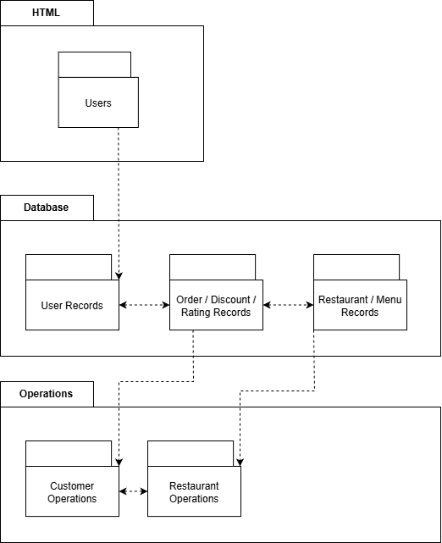

Software design description

HTML Layer

Component interfaces
Component Interfaces
The HTML Layer acts as the system's external interface, communicating with the user and the database layer immediately below it.
2) Users
Manages all user-facing interactions (displaying screens, capturing input) and communicates with the backend operations layer to process requests.
Input Data:
- From User:
- User Credentials (Username, Password)
- Search Queries (query string (keyword), city)
- Item Selections (menuItemId, quantity)
- Registration Credentials (username, password, userType (Customer / Manager)
- From Database:
- Authentication Status (True/False)
- Registration Status (Proper/Not Proper)
- Search Results
- Order Status (Confirmed/Denied)
Output Data:
- To User:
- Display Screens (Login, Register, Main Menu, Search Results)
- Confirmation/Error Messages
- To Database:
- Request for User Authentication
- Request to Register User
- Request to Search
- Request to Place Order

Component design description
The Food Ordering System follows a layered architecture where each layer has a clear responsibility. In the HTML Layer (User Interface), there is a single class, Users, which manages all communication between the end-user and the system by displaying pages such as login, restaurant list, menu details, order placement, discount application, and order tracking.
The Business Logic Layer processes all requests coming from the Users interface, applies system rules (pricing, discounts, order status updates, ratings), and coordinates operations using controllers, services, and DAOs.
The Database Layer manages persistent data in MySQL. The DatabaseConnectionManager establishes, manages, and releases database connections, while DAO classes—UserDAO, RestaurantDAO, MenuDAO, and OrderDAO—performCRUD operations on their respective tables using secure SQL execution practices.
These layers interact sequentially: the Users interface sends a request to the Business Logic Layer, which communicates with the Database Layer and returns the processed results back to the user.

HTML Layer - Class Diagram
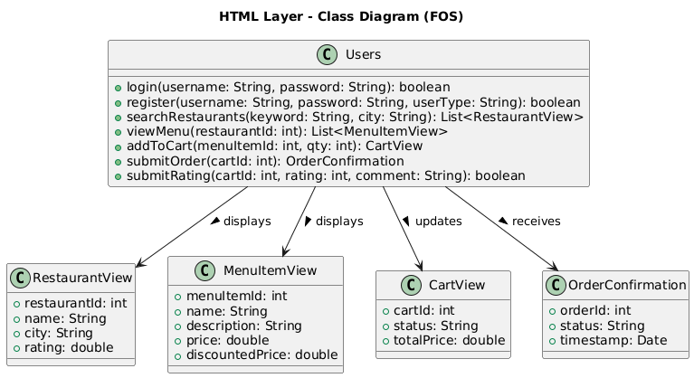

Workflows and algorithms

User Authentication Workflow
When the user submits login credentials, the Users interface calls authenticateUser() in UserDAO, which obtains a connection from DatabaseConnectionManager and queries the database for the stored password hash. The hash is compared with the user-entered password, and a success or failure response is returned to the GUI so it can display the appropriate message.
Activity Diagram: Food Ordering Workflow
When a customer places an order, the system checks item availability and then begins a transaction. It inserts the order, records ordered items, and updates related data. If all steps succeed, the transaction is committed and the order confirmation is shown; otherwise, it is rolled back and an error message is displayed. All SQL operations use sanitized inputs.
Key Algorithms
- Input Sanitization: Removes/escapes harmful input before any SQL execution.
- Transaction Management: Multi-step operations are committed only if every step succeeds; otherwise rolled back.

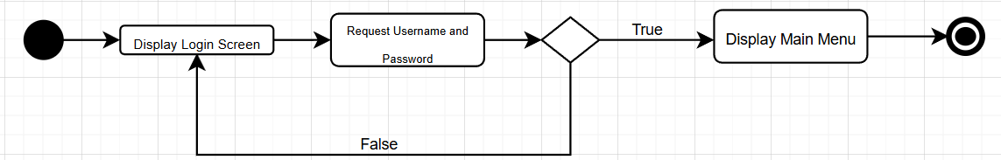

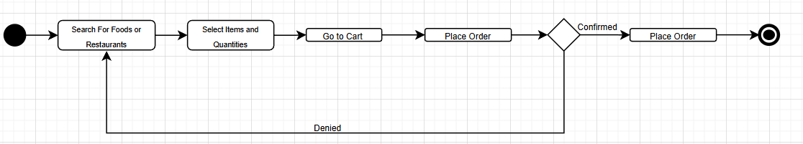

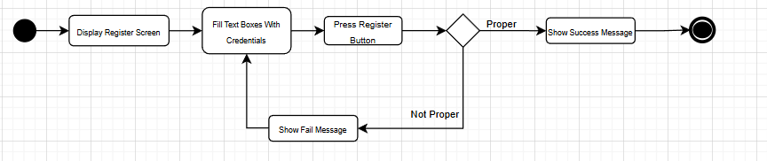
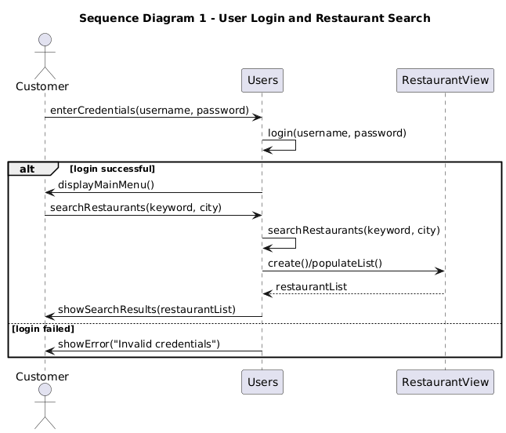

Shows the interaction flow for user login and restaurant search within the HTML Layer.
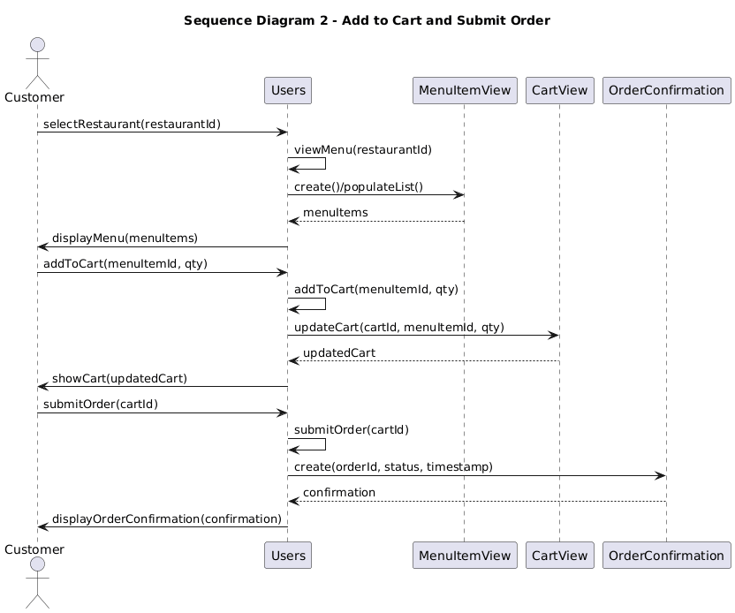

Shows how the user views a menu, updates the cart, and submits an order through the HTML Layer.

Software requirements mapping
Since the HTML layer handles all display and interface operations, it plays a part in almost all requirements.

User Requirements
SRS-FOS-001, SRS-FOS-002, SRS-FOS-003, SRS-FOS-004, SRS-FOS-005, SRS-FOS-006, SRS-FOS-007, SRS-FOS-008, SRS-FOS-009

System Requirements
SRS-FOS-001.1, SRS-FOS-002.1, SRS-FOS-002.2, SRS-FOS-003.1, SRS-FOS-003.2, SRS-FOS-003.3, SRS-FOS-003.4, SRS-FOS-004.1, SRS-FOS-004.2, SRS-FOS-005.2, SRS-FOS-006.1, SRS-FOS-006.2, SRS-FOS-007.1, SRS-FOS-007.2, SRS-FOS-008.1, SRS-FOS-008.2, SRS-FOS-009.2

Database Layer

Component interfaces
1) UserDataAccess
Provides operations related to user accounts (customers and managers), including registration and login.
Input data:
- Registration data: username, password, userType (Customer / Manager)
- For customers: address, city, phone
- For managers: restaurantName, restaurantAddress, restaurantCity, cuisineType
- Login data: username, password, userType
Output data:
- A ‘User’ object (or equivalent record) containing fields such as ‘UserID, Username, UserType’
- Lists of restaurants managed by a given manager (for example when loading the manager dashboard)

Method Signature:
boolean registerUser(String username, String password, String userType);
User getUser(String username, String password);
List<Restaurant> getManagedRestaurants(int userId);

2) RestaurantDataAccess
Provides read and write access to restaurant and menu-related data.
Input data:
- Manager identifier: userId (to retrieve restaurants managed by a user)
- Restaurant identifier: restaurantId (to load menu items, statistics, ratings)
- Menu item data: name, description, price, image
- Search parameters: query string (keyword), city of the user
- Keyword and discount configuration: keyword, menuItemId, discountValue, startDate, endDate
Output data:
- Lists of ‘Restaurant’ objects (for manager dashboards and customer search results)
- Lists of ‘MenuItem’ objects (menu items for a selected restaurant)
- Lists of keywords associated with a restaurant
- Lists of discounted menu items with base price, discount rate, discount time interval, and current discounted price
- Aggregated statistics such as total revenue, total order count, item-level revenue, and top customers

Method Signature:
List<Restaurant> searchRestaurants(String keyword, String city);
List<MenuItem> getMenuItems(int restaurantId);
boolean addMenuItem(MenuItem item);
boolean addKeyword(int restaurantId, String keyword);
List<Discount> getActiveDiscounts(int menuItemId, Date date);
Restaurant getRestaurantById(int restaurantId);

3) OrderDataAccess
Handles all persistent data related to carts and orders.
Input data:
- userId of the customer
- restaurantId inferred from selected menu items
- Cart operations: cartId, menuItemId, quantity
- Order status updates: cartId, new Status (e.g., 'Sent', 'Accepted')
Output data:
- Current active ‘Cart’ for a user (with CartID and Status)
- Items inside a cart, including MenuItemID, name, description, image, quantity, base price, active discount, and effective price
- Lists of orders for a restaurant (used by managers to see incoming “tickets”)
- Total cart price calculated from menu item prices, discounts, and quantities
- Updated order records with the new ‘Status’ value (e.g., 'Sent', 'Accepted').

Method Signature:
Cart getActiveCart(int userId);
boolean createCart(int userId);
boolean addOrUpdateCartItem(int cartId, int menuItemId, int quantity);
List<CartItem> getCartItems(int cartId);
boolean updateCartStatus(int cartId, String status);
List<Cart> getSubmittedOrders(int userId);
List<Cart> getRestaurantOrders(int restaurantId);

4) RatingDataAccess
Provides access to ratings and comments submitted by customers for completed orders.
Input data:
- Rating form data: userId, cartId, restaurantId, numeric rating (e.g., 1–5), and free-text comment
- Queries based on restaurantId to show feedback for a specific restaurant
Output data:
- Lists of rating records containing Username, Rating, Comment, and RatingDate
- Average rating value for a restaurant (computed from existing rating records)
- Boolean flags indicating successful insertion of new rating records and their relationships (WrittenBy, ForRestaurant)
Method Signature:
boolean submitRating(int userId, int cartId, int restaurantId, int rating, String comment);
List<Rating> getRatingsForRestaurant(int restaurantId);
double getAverageRating(int restaurantId);

Component design description

The Database Layer is divided into four main parts: UserData, RestaurantData, OrderData, and RatingData. Each part focuses on one area of the system and contains the tables related to that area.
The UserData package stores all information about users. The main table is ‘User’, and the additional tables ‘UserAddress’ and ‘UserPhoneNumber’ keep optional contact details. The Manages table connects managers to the restaurants they manage.
The RestaurantData package includes everything related to restaurants. The ‘Restaurant’ table stores basic restaurant information, while ‘MenuItem’ stores the food items offered by each restaurant. The ‘Keyword’ table helps with searching by linking restaurants to multiple search tags. The ‘Discount’ table stores optional promotions for menu items.
The OrderData package represents the customer’s cart and order. Cart stores the order status, and ‘CartItem’ stores each selected menu item and its quantity. Prices and discounts are not saved directly in the cart; instead, they are taken from the MenuItem and Discount tables when needed.
The RatingData package stores customer feedback. The ‘Rating’ table contains the rating value, comment, and date. The ‘WrittenBy’ and ‘ForRestaurant’ tables link each rating to the user who wrote it and the restaurant that was rated.
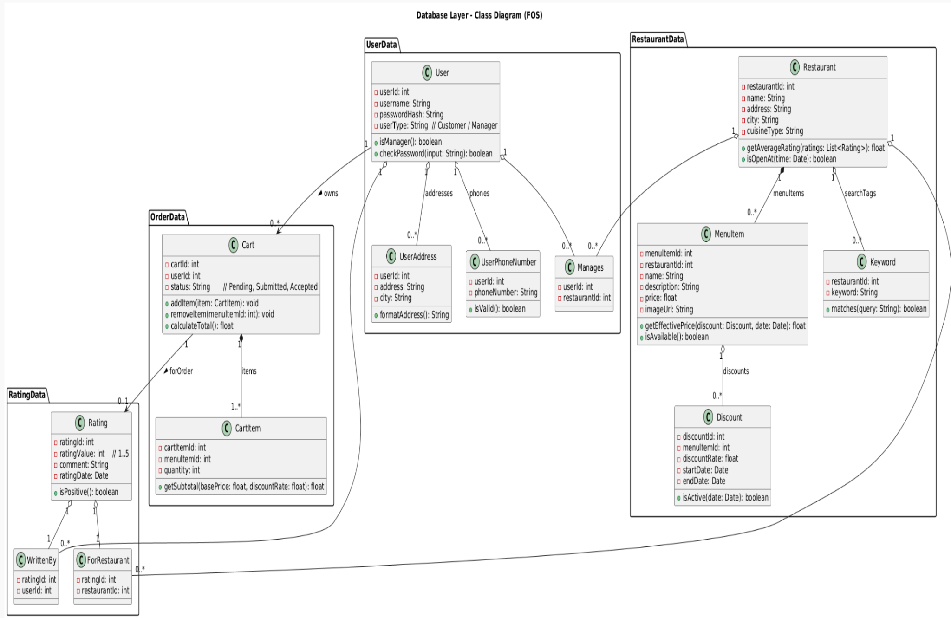
This diagram presents the object-oriented design of the database layer, including model classes, their operations, and the relationships between key entities such as users, restaurants, menu items, carts, and ratings. Proper UML relations (composition, aggregation, association) are used to represent structural ownership and logical dependencies.

Workflows and algorithms
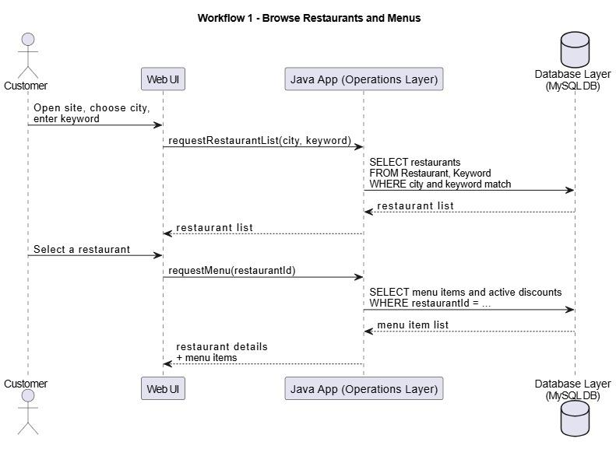

- The customer opens the website, selects a city, and enters an optional search keyword through the Web UI.
- The Web UI sends a request to the Java App to retrieve a list of restaurants matching the given city and keyword.
- The Java App queries the Database Layer by selecting restaurants (and related keyword records) filtered by the provided city and keyword.
- The Database Layer returns the matching restaurant records to the Java App.
- The Java App forwards the restaurant list to the Web UI, which displays them to the customer.
- When the customer selects a specific restaurant, the Web UI requests the menu for that restaurant from the Java App.
- The Java App queries the Database Layer for all menu items belonging to the selected restaurant and checks for active discounts based on the current date.
- The Database Layer returns the menu item list (including discount information, if available).
- The Java App sends the restaurant details and menu items back to the Web UI, which renders the final menu page for the customer.

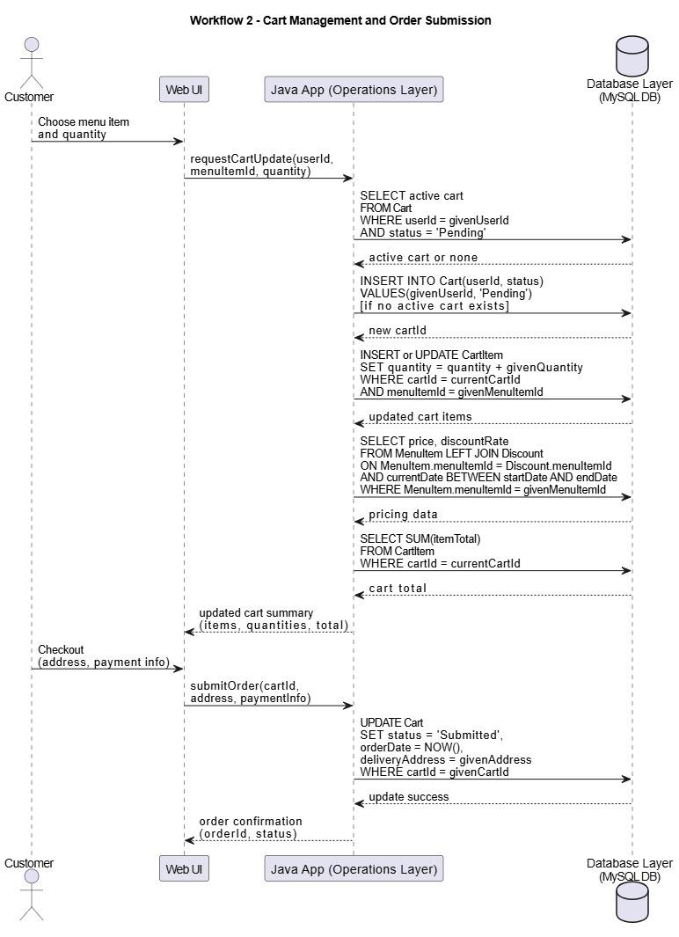

- The customer selects a menu item and specifies a quantity through the Web UI.
- The Web UI sends a cart update request to the Java App with the user ID, menu item ID, and quantity.
- The Java App queries the Database Layer to determine whether a pending cart already exists for the given user.
- If no active cart is found, the Java App creates a new cart record with status Pending.
- The Java App inserts or updates the corresponding ‘CartItem’ entry by either adding the new item or increasing the quantity.
- The Java App retrieves the base price of the menu item and checks the Discount table for any active discount that applies to the selected item.
- The Java App calculates the subtotal and cart total by summing item totals from the ‘CartItem’ records.
- The Web UI receives the updated cart summary, including items, quantities, pricing, and discounts.
- During checkout, the customer provides address and payment information, which is sent to the Java App.
- The Java App updates the cart’s status to Submitted, stores the submission timestamp, and records the delivery address in the database.
- The Web UI receives the final order confirmation containing the order ID and order status information.

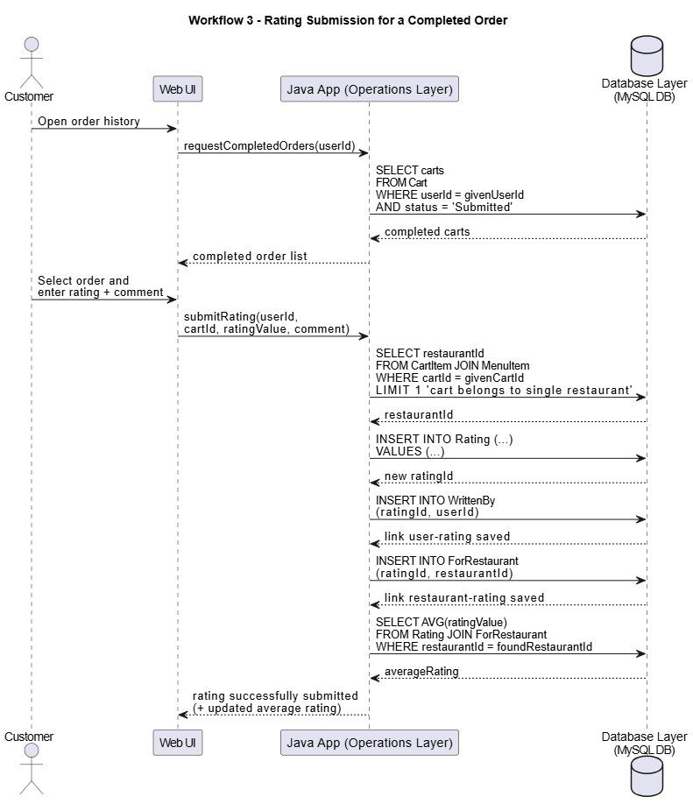
- The customer opens the order history page through the Web UI.
- The Web UI requests all completed (submitted) orders for the given user from the Java App.
- The Java App queries the Database Layer for carts associated with the user that have a ‘Submitted’ status.
- The Database Layer returns the list of completed orders to the Java App, which forwards them to the Web UI.
- The customer selects an order and enters a rating value and comment.
- The Web UI sends the rating data (user ID, cart ID, rating value, and comment) to the Java App.
- The Java App queries the Database Layer to identify which restaurant the cart belongs to.
- The Database Layer returns the restaurant ID.
- The Java App inserts a new ‘Rating’ record and receives the generated rating ID.
- The Java App creates a link between the rating and the user by inserting into the ‘WrittenBy’ table.
- The Java App then links the rating to the corresponding restaurant using the ‘ForRestaurant’ table.
- (Optional) The Java App queries the Database Layer to compute the latest average rating for the restaurant.
- The Web UI receives a confirmation that the rating was successfully submitted and may optionally display the updated average rating.

Software requirements mapping
Since the Database Layer stores and retrieves all core system data (users, restaurants, menus, carts, orders, ratings), it supports almost all functional and non-functional requirements of the system.

User Requirements
User Registration & Login
SRS-FOS-001,SRS-FOS-002
Restaurant Search & Browsing
SRS-FOS-003, SRS-FOS-004
Cart and Order Management
SRS-FOS-005,SRS-FOS-006
Rating Submission
SRS-FOS-007
Restaurant & Menu Viewing
SRS-FOS-008, SRS-FOS-009

System Requirements
SRS-FOS-001.1, SRS-FOS-002.1, SRS-FOS-002.2, SRS-FOS-003.1, SRS-FOS-003.2, SRS-FOS-003.3, SRS-FOS-003.4, SRS-FOS-004.1, SRS-FOS-004.2, SRS-FOS-005.2, SRS-FOS-006.1, SRS-FOS-006.2, SRS-FOS-007.1, SRS-FOS-007.2, SRS-FOS-008.1, SRS-FOS-008.2, SRS-FOS-009.2

Business Logic Layer
The Business Logic Layer acts as the intermediary between the HTML Layer and the Database Layer. It processes requests coming from the UI, enforces system rules (pricing, discount calculation, cart updates, order transitions, rating validation), and delegates data operations to the corresponding DAO classes.

Component interfaces
1) UserService
Provides operations for user authentication and registration by coordinating the UI and Database Layer.
Input data:
- Login credentials: username, password
- Registration data: username, password, userType
- Manager requests: userId
Output data:
- Authentication result (success / fail)
- A User object containing fields such as UserID, Username, UserType
- List of restaurants managed by a manager

Method Signature:
User login(String username, String password);
boolean registerUser(User user);
List<Restaurant> getManagedRestaurants(int userId);

2) RestaurantService
Handles restaurant search, menu retrieval, and discount evaluation.
Input data:
- Search parameters: keyword, city
- Restaurant identifier: restaurantId
- Menu item identifier: menuItemId
Output data:
- List of restaurants matching search criteria
- List of menu items for the selected restaurant
- List of active discounts for a menu item

Method Signature:
List<Restaurant> searchRestaurants(String keyword, String city);
List<MenuItem> getMenu(int restaurantId);
List<Discount> getActiveDiscounts(int menuItemId);
3) OrderService
Coordinates cart updates and order submission operations.
Input data:
- User identifier: userId
- Cart update parameters: menuItemId, quantity
- Order submission: cartId

Output data:
- Current active cart (items, quantities, prices)
- Updated cart after an operation
- Order confirmation object

Method Signature:
Cart getActiveCart(int userId);
Cart addToCart(int userId, int menuItemId, int quantity);
OrderConfirmation submitOrder(int cartId);

4) RatingService
Coordinates cart updates and order submission operations.
Input data:
- Rating form inputs: userId, cartId, restaurantId
- Rating details: rating (1–5), comment

Output data:
- Boolean success flag after submitting rating
- List of ratings for a restaurant
- Average rating value

Method Signature:
boolean submitRating(int userId, int cartId, int restaurantId, int rating, String comment);
List<Rating> getRestaurantRatings(int restaurantId);
double getAverageRating(int restaurantId);

Component design description
The Business Logic Layer serves as the core of the system, implementing business rules through two interacting components: Customer Operations and Restaurant Operations. Customer Operations focuses on the consumer workflow, processing logic for shopping carts, order submissions, and rating entries by utilizing data from User and Order records. It ensures that customer actions are validated, discounts are applied correctly, and totals are calculated.
Restaurant Operations manages the administrative logic, handling menu organization and the retrieval of restaurant-specific data. These two components share a direct link to synchronize events; when Customer Operations finalizes a transaction, it coordinates with Restaurant Operations to ensure the venue receives and processes the request. This layer seperates the raw database tables from the UI, ensuring that only processed, valid information is presented to the user.
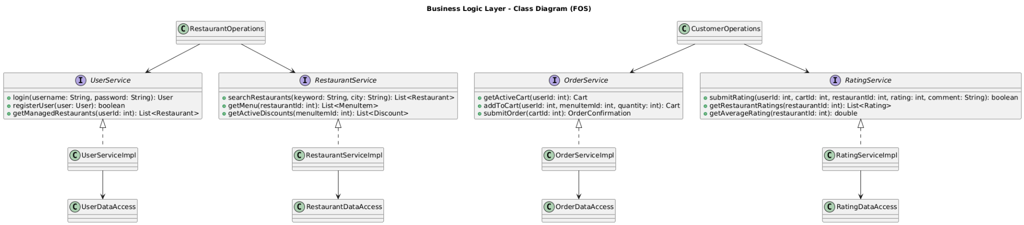

Workflows and algorithms

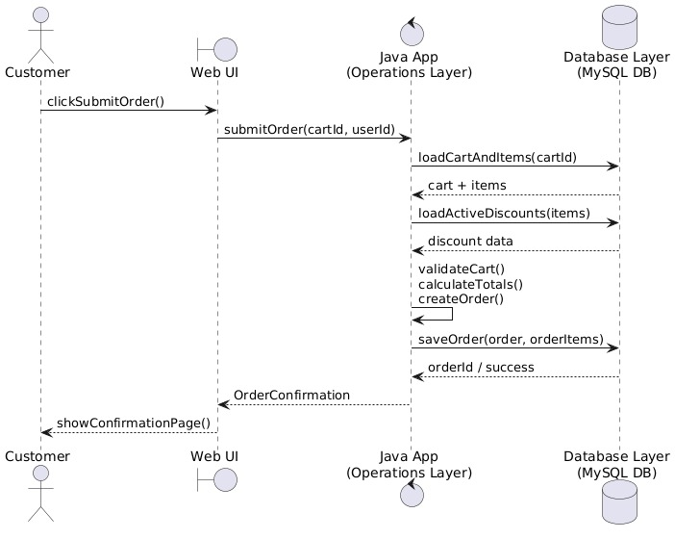

Software requirements mapping
The Business Logic Layer is responsible for implementing system rules, coordinating UI requests and database operations, and ensuring the correctness of workflows such as login, restaurant search, cart operations, order submission, and rating processing.

User Requirements
User Registration & Login
SRS-FOS-001, SRS-FOS-002
Restaurant Search & Browsing
SRS-FOS-003, SRS-FOS-004
Cart and Order Management
SRS-FOS-005,SRS-FOS-006
Rating Submission
SRS-FOS-007
Restaurant & Menu Viewing
SRS-FOS-008, SRS-FOS-009

System Requirements
SRS-FOS-001.1, SRS-FOS-002.1, SRS-FOS-002.2, SRS-FOS-003.1, SRS-FOS-003.2, SRS-FOS-003.3, SRS-FOS-003.4, SRS-FOS-004.1, SRS-FOS-004.2, SRS-FOS-005.2, SRS-FOS-006.1, SRS-FOS-006.2, SRS-FOS-007.1, SRS-FOS-007.2, SRS-FOS-008.1, SRS-FOS-008.2, SRS-FOS-009.2

COTS Identification
COTS (commercial off-the-shelf) libraries used in our FOS for writing SQL queries on MySQL:
1. JDBC(JavaDatabase Connectivity)
● Version: Included in Java SE 8+ (no standalone version)
● DownloadURL: https://www.oracle.com/java/technologies/javase-downloads.html
● LicenseType: Oracle Binary Code License / GPL with Classpath Exception

